

APPLICATION PROGRAMMING

SEM-2

NAME- GAURAV SINGH

BRANCH- CSE

ROLL NO. 11911067

CREATING A HTML WEBPAGE FORMS

|  |  |
| --- | --- |
|  | <!DOCTYPE html> |
|  | <html> |
|  | <head> |
|  | <title>registration form</title> |
|  | </head> |
|  | <body> |
|  | <form> |
|  | <table> |
|  | <tr> |
|  | <td> |
|  | NAME: |
|  | </td> |
|  | <td> |
|  | <input type="text" placeholder="NAME" name=""> |
|  | </td> |
|  | </tr> |
|  | <tr> |
|  | <td> |
|  | PASSWORD: |
|  | </td> |
|  | <td> |
|  | <input type="password" placeholder="PASSWORD" name=""> |
|  | </td> |
|  | </tr> |
|  | <tr> |
|  | <td> |
|  | GENDER: |
|  | </td> |
|  | <td> |
|  | <input type="radio" name="GENDER">male |
|  | <input type="radio" name="GENDER">female |
|  | </td> |
|  | </tr> |
|  | <tr> |
|  | <td> |
|  | EMAIL: |
|  | </td> |
|  | <td> |
|  | <input type="mail" placeholder="EMAIL" name=""> |
|  | </td> |
|  | </tr> |
|  | <tr> |
|  | <td> |
|  | <input type="submit" value="submit" name=""> |
|  | </td> |
|  | </tr> |
|  | </table> |
|  | </form> |
|  |  |
|  | </body> |
|  | </html> |

OUTPUT-

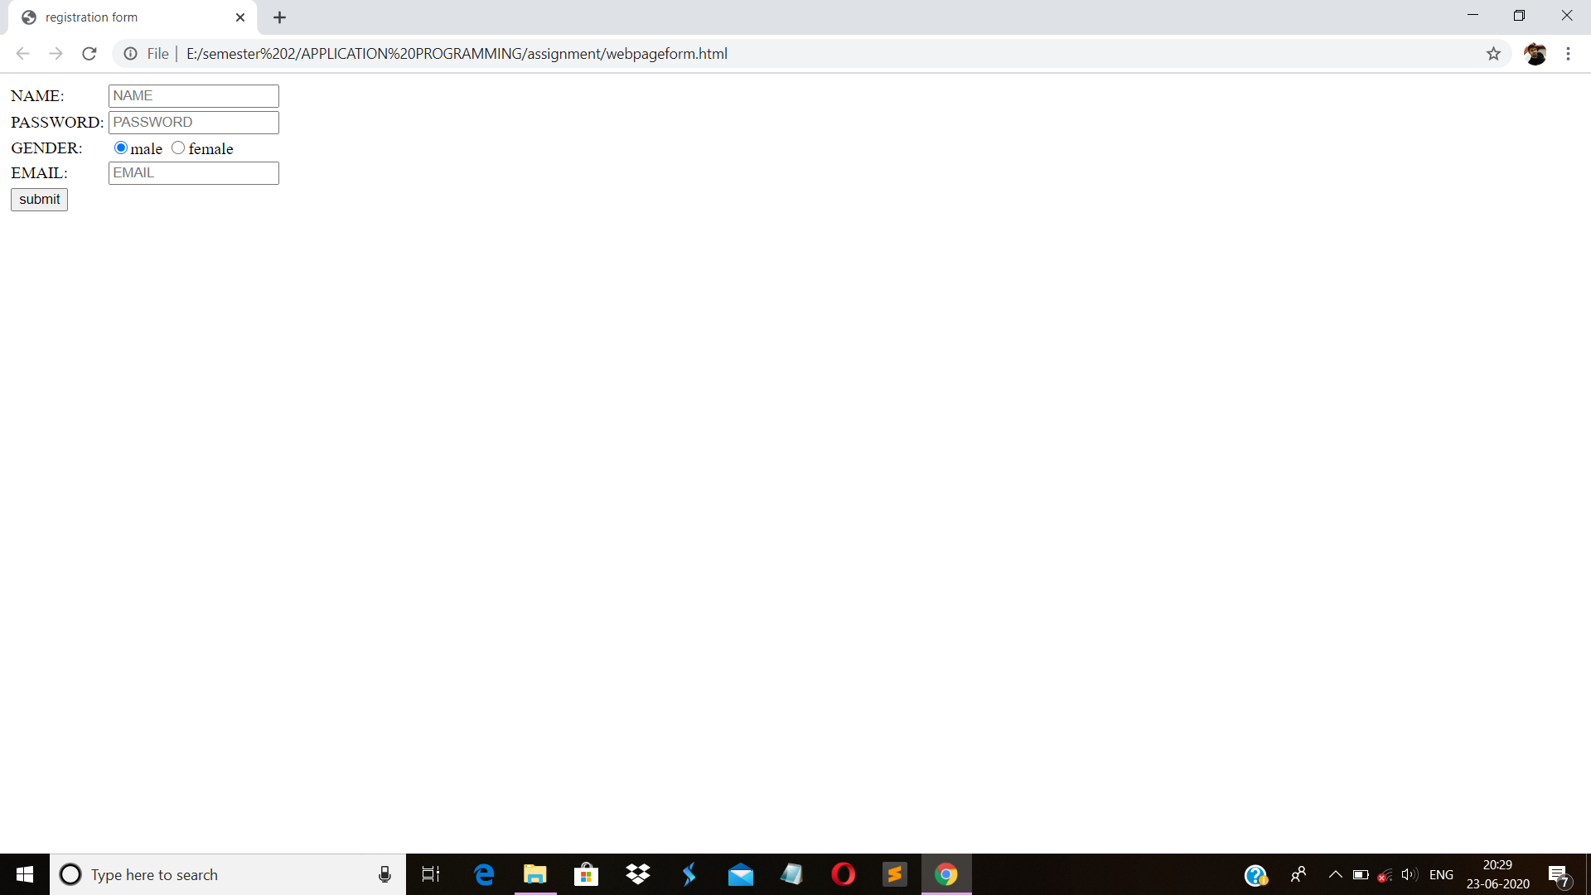

CREATING HOME PAGE USING HTML

|  |  |
| --- | --- |
|  | <!DOCTYPE html> |
|  | <html> |
|  |  |
|  | <head> |
|  | <title>Our Company</title> |
|  | </head> |
|  |  |
|  | <body> |
|  |  |
|  | <h1>Welcome to my homepage</h1> |
|  | <h2>Web Site Main Ingredients:</h2> |
|  |  |
|  | <p>Pages (HTML)</p> |
|  | <p>Style Sheets (CSS)</p> |
|  | <p>Computer Code (JavaScript)</p> |
|  | <p>Live Data (Files and Databases)</p> |
|  |  |
|  | </body> |
|  |  |
|  | </html> |
|  |  |

OUTPUT-

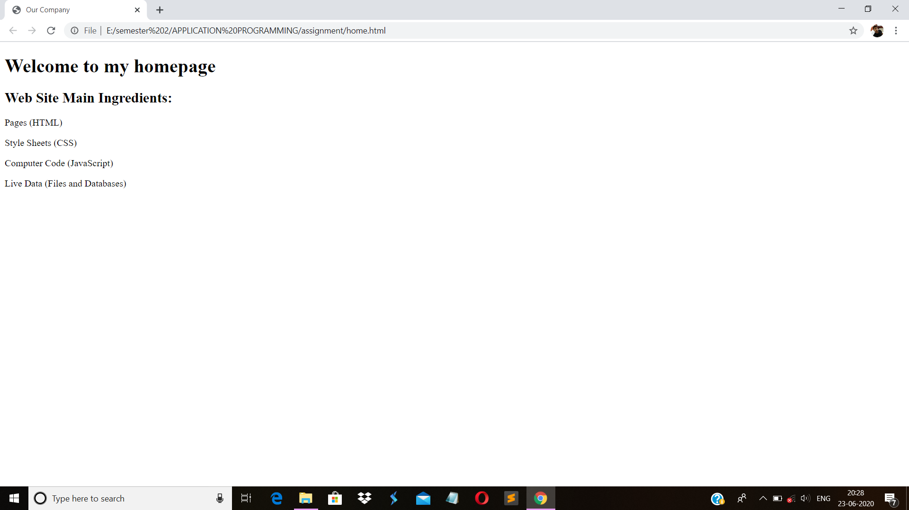

CREATING WEBPAGE USING CSS

|  |  |
| --- | --- |
|  | <!DOCTYPE html> |
|  | <html> |
|  | <head> |
|  | <meta name="viewport" content="width=device-width, initial-scale=1.0"> |
|  | </head> |
|  | <body> |
|  |  |
|  | <h2>Setting the Viewport</h2> |
|  | <p>This is my first webpage using css and xhtml.</p> |
|  |  |
|  | </body> |
|  | </html> |
|  | OUTPUT-C:\Users\91884\Pictures\Screenshots\Screenshot (72).png |

Creating website using php

|  |  |
| --- | --- |
|  | <!DOCTYPE html> |
|  | <html> |
|  | <head> |
|  | <title>my first php website</title> |
|  | </head> |
|  | <body> |
|  | <p>hello world</p> |
|  | </body> |
|  | </html> |

Output-

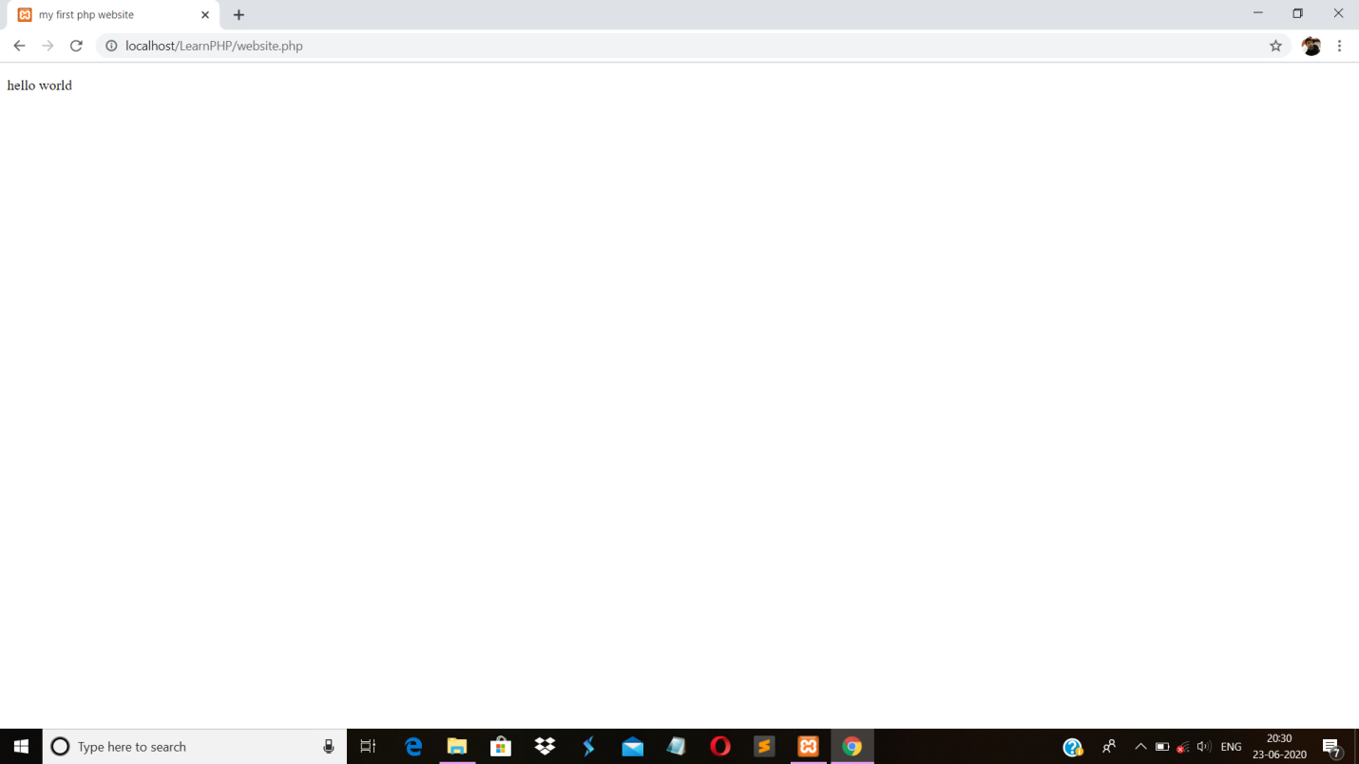

Creating form using html

|  |  |
| --- | --- |
|  | <html> |
|  | <head> |
|  | <title>form creating</title> |
|  | <style> |
|  | body { |
|  | font-family: Arial; |
|  | background-color: lightblue; |
|  | } |
|  |  |
|  |  |
|  |  |
|  | /* Full-width input fields */ |
|  | input[type=text], input[type=password] { |
|  | width: 100%; |
|  | padding: 10px; |
|  | margin: 5px 0 20px 0; |
|  | display: inline-block; |
|  | border: none; |
|  | background: #f1f1f1; |
|  | } |
|  | hr { |
|  | border: 1px solid #f1f1f1; |
|  | margin-bottom: 25px; |
|  | } |
|  |  |
|  | .submit { |
|  | background-color: #4CAF50; |
|  | color: white; |
|  | padding: 15px 10px; |
|  | margin: 8px 10px; |
|  | border: none; |
|  | cursor: pointer; |
|  | width: 100%; |
|  | opacity: 0.9; |
|  | } |
|  |  |
|  | /* Add a blue text color to links */ |
|  | a { |
|  | color: blue; |
|  | } |
|  |  |
|  | </style> |
|  | <script> |
|  | function validateForm() |
|  | { |
|  | var x = document.forms["myForm"]["fname"].value; |
|  | if(x=="" || x==null) |
|  | { |
|  | alert("First name is required"); |
|  | return false; |
|  | } |
|  | } |
|  | </script> |
|  | </head> |
|  | <body> |
|  |  |
|  | <form name="myForm" action="welcome.php" onsubmit="return validateForm()" method="get" required> |
|  | <h1>Registration form</h1> |
|  | <p>Please fill the data for registration</p> |
|  | <hr> |
|  | <lable for="fname"><b>first name:</b></lable> <input type="text" id="fname"placeholder="Enter your first name">&nbsp&nbsp&nbsp |
|  | <lable for="lname"><b>last name:</b></lable> |
|  | <input type="text" placeholder="Enter your last name"><br><br> |
|  | <b>Email Id:</b><input type="text" placeholder="Enter your mail id">&nbsp&nbsp&nbsp&nbsp <b>select your gender</b><input type="radio" name="gender" id="male" value="male"><lable for="male">male</lable>&nbsp<input type="radio" name="gender" id="female" value="female"><lable for="female">female</lable>&nbsp<input type="radio" name="gender" id="other" value="other"><lable for="other">other</lable><br><br> |
|  | <b>password:</b><input type="password" placeholder="Enter your password"><br><br> |
|  | <b>Repeat Password :</b><input type="password" placeholder="Repeat password"><br><br> |
|  | <p> I accept all the <a href="#"> terms & condition </a>.&nbsp <input type="radio" value="ok"></p><br> |
|  | <button type="submit" class="submit">submit</button> |
|  | <center><p>Already have an account? <a href="#">Sign in</a>.</p></center> |
|  | </form> |
|  | </body> |
|  | </html> |
|  |  |

Output

